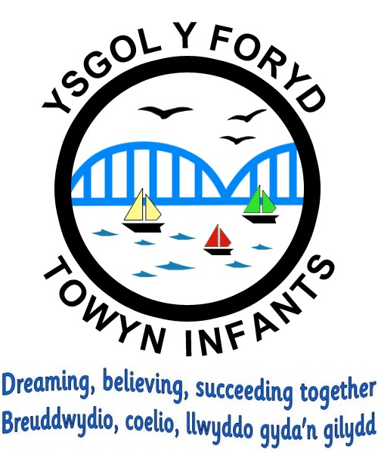

Sun safe Policy

Policy reviewed: Summer 2023
Policy valid until: Summer 2027
Policy owned by: The Headteacher

Headteacher: Mrs Nicola Rowlands

Chair of Governors: Mr Gary Young
SUN POLICY

At Ysgol y Foryd we acknowledge the importance of sun protection and want staff and pupils to enjoy the sun safely. We will work with staff, pupils and parents to achieve this through:

EDUCATION
- All pupils will have at least one Sun Safety lesson per year.
- We will talk about how to be Sun Safe during a themed assembly during the summer term
- Guidance for Parents and guardians is in the school prospectus. A letter or information on Class Dojo will also be shared during the summer term, or when required explaining what the school is doing about sun protection and how they can help.
- Information on sun safety is provided in the staff room during the summer months.

PROTECTION
Shade:
- We will encourage students to sit/play in the shade where it is available.
- Trees have been planted around the school.
- Sheltered areas have been built over recent years to provide shade.
- Shade is provided by using umbrella over the tables and fabric over gazebos.

Timetabling:
- We encourage hats, sensible clothing and sunscreen are all worn to prevent sunburn, especially between 11am and 3pm.
- Staff decide on the appropriate amount of time spent outdoors for learning.
- SLT make decisions about reducing playtimes in very hot weather.

Clothing:
- Children are encouraged to wear hats.
- Teachers are encouraged to wear hats to provide a good role model.
- Pupils are welcome to wear blue gingham summer dresses or grey shorts.

Sunscreen:
- Sunscreen use will be encouraged during the summer at lunch breaks, during PE lessons and on school trips. Parents must provide this for their children who will be supervised while they apply this themselves.

We will monitor our progress and review the policy regularly.

